Quadratic Equation Practice

Equation | a | b | c | Opens up or down | Line of Symmetry | Vertex | Min or Max | Domain | Range
- F(x) = 2x² + 4x + 1

- F(x) = -2x² – 6x – 3

- F(x) = 8x² – 5

- F(x) = 5x² – 3x + 4

- F(x) = -3x² – 24x + 7

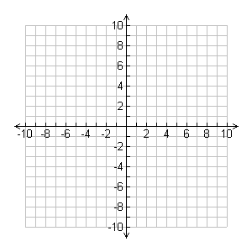
- Complete the table for the given quadratic function and graph it.
x | y
-8
-4
0
4
8
y = $\frac{1}{8} x$²

Identify the domain and range of this quadratic function.

- Evaluate the quadratic functions for the given value. Show your work.
f(x) = 2x² – 3x + 5; f(4) f(x) = -4x² + 7x; f(-2)

